Defining the Helical Collection Path using Raster Tab Results
When it is difficult to see your crystal in the sample loop or the crystal is split or highly mosaic, one may need to use low dose X-ray Rastering to define the location of the well diffracting parts of the crystal in 3 dimensions before Helical Data collection. To fully define the volume of the crystal to use for Helical data collection, the rastering results should first define a 2D plane containing the crystal (Figure A) and then the third dimension of the two end points of the crystal should be defined by collecting two 1D rater scans 90 degrees away (Figure B). These raster scans should be collected from within the Raster interface. The procedure for setting up a Helical Data Collection using these raster results is described in the following paragraph.
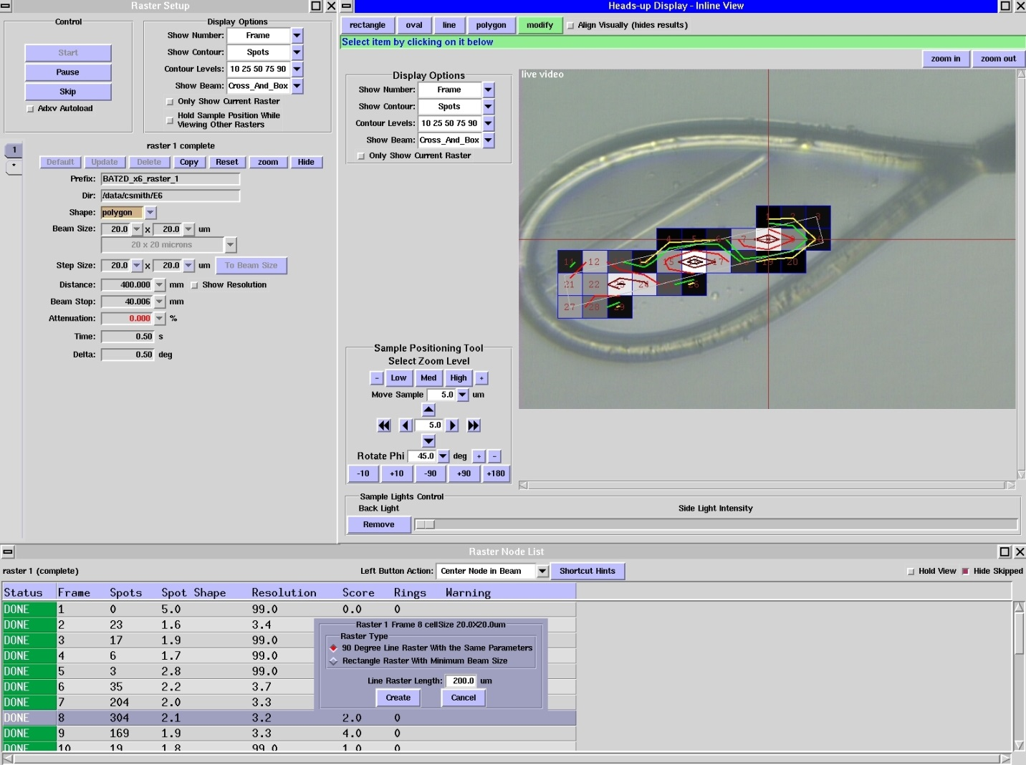
- RASTER TAB Results: 2D scan of a crystal along the face of the loop. One end position of the crystal has been centered in the X-ray beam position (red cross hairs) to prepare for setting up a linear (1D scan) 90 degrees away using the ‘Raster Mode List’ (located at the bottom of the figure).

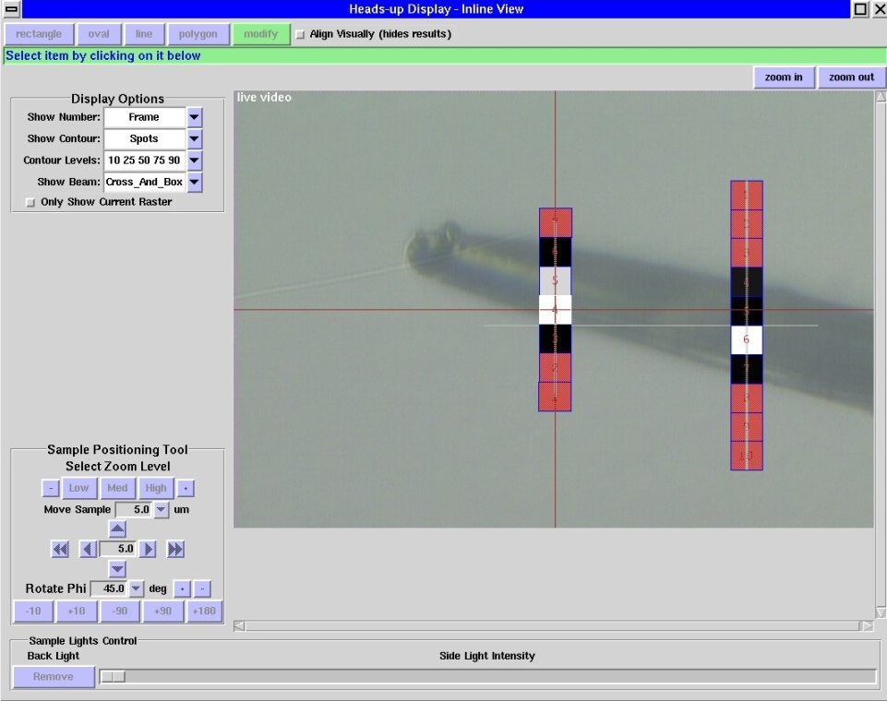
- RASTER TAB Results: Two linear (1D) scans at end positions of the crystal 90 degrees away from the 2D scan shown in Figure A. The cross hair is located at a starting position for helical data collection.
The helical data collection setup should be done from inside the Helical Tab, but you should switch back to the Raster Tab to select which Raster results to display. To display your Raster Tab results in the Helical Tab, click on the “Show Rasters” button (Figure C). As you may have collected many ‘rasters’ from within the Raster tab, to select which raster results to be displayed in the Helical Tab use the Raster Setup Tab -> Display Options and select the specific raster sub-tab and then select the “only show current raster” option.
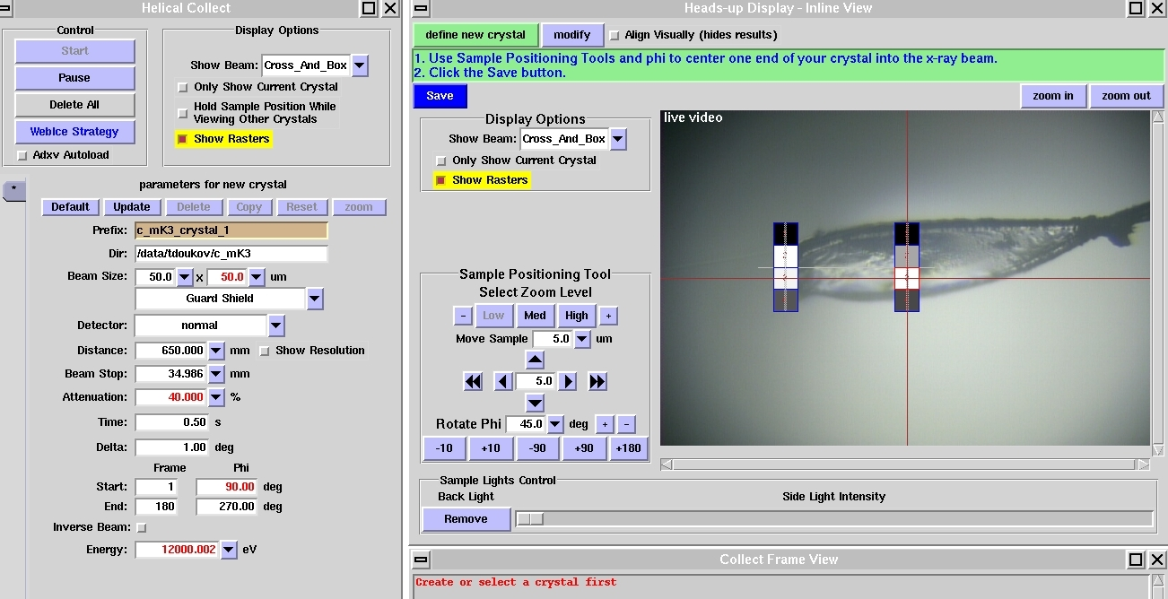
- HELICAL TAB with the Raster results displayed to aid in defining the end of the crystal. The ‘Show Rasters’ Button is highlighted in yellow.

From within the Helical tab, to define the starting end of the crystal for helical data collection, with the “Show Rasters” button engaged, first position the end of the crystal into the X-ray beam by clicking on the raster peak in the face-on view. After the crystal is centered in one direction, it needs to be centered 90 degrees away to be fully defined in 3D, ensuring it will stay on the rotation axis during data collection. To do this rotate by 90 degrees to see the 2D Raster results and position the end of the crystal into the X-ray beam using this view. Click the blue ‘Save’ button from within the Helical Tab Heads-up display. Repeat this procedure using the Raster results to position and define, in 3D, the other end of the crystal. Click the blue ‘Save’ button. Two orthogonal views depicting an example comparison of raster results and a helical data collection setup are shown in figure D.

Raster Results | Helical Data Collection Setup
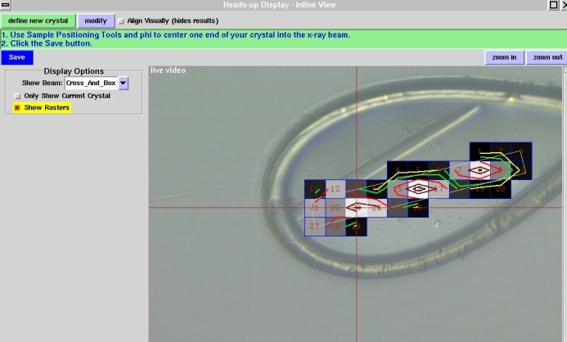 | 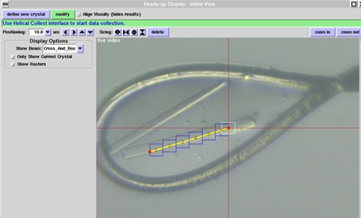
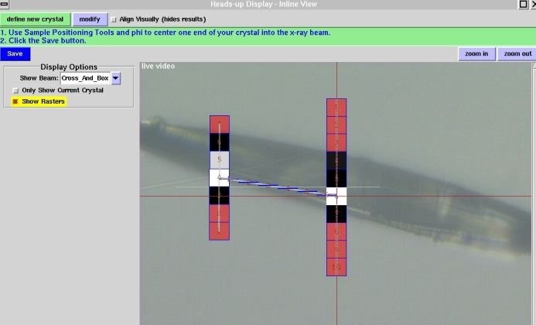  90 degree view | 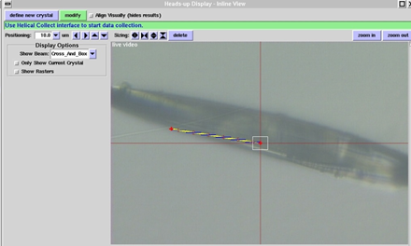
(D): Comparison of the Raster results (column 1) and locations used for Helical data collection (column 2).

